COST ANALYSIS /AZURE CALCULATOR

1.OPEN AZURE CAKCULATOR PORTAL AND SERACH FOR Vm CREATION

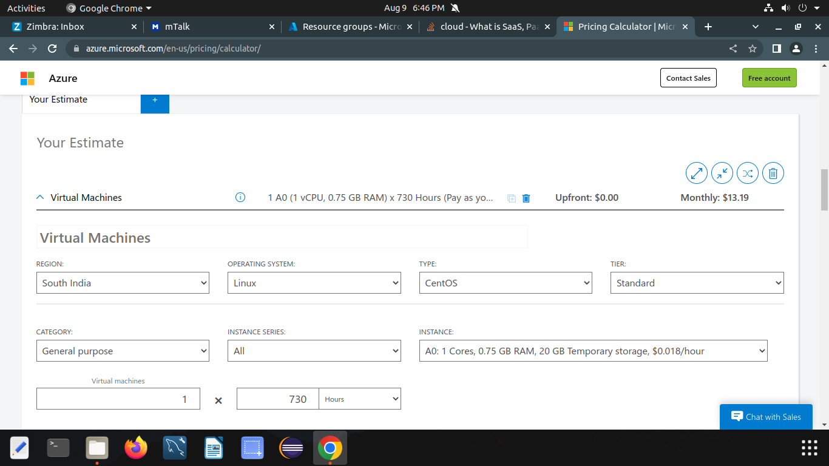

2.Add postgresql

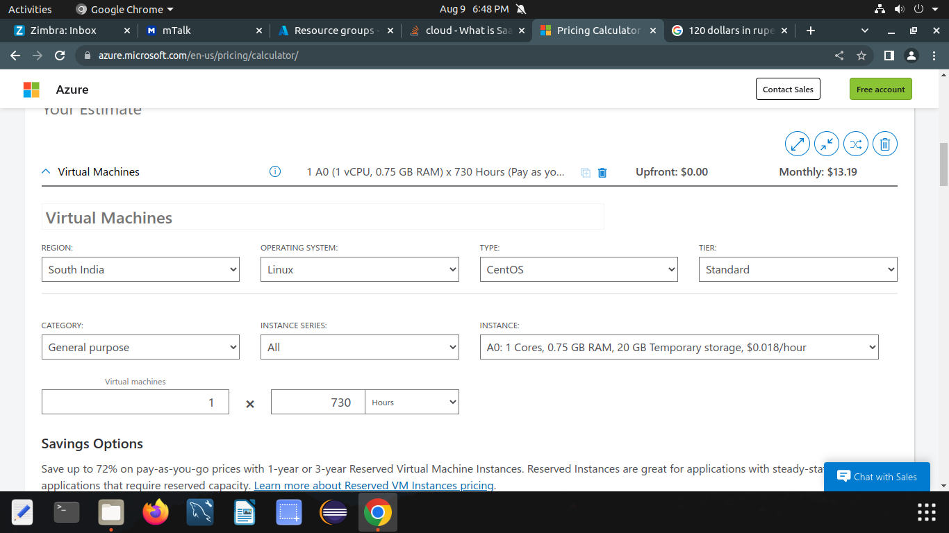

3.Add Container registry and Virtual Network.

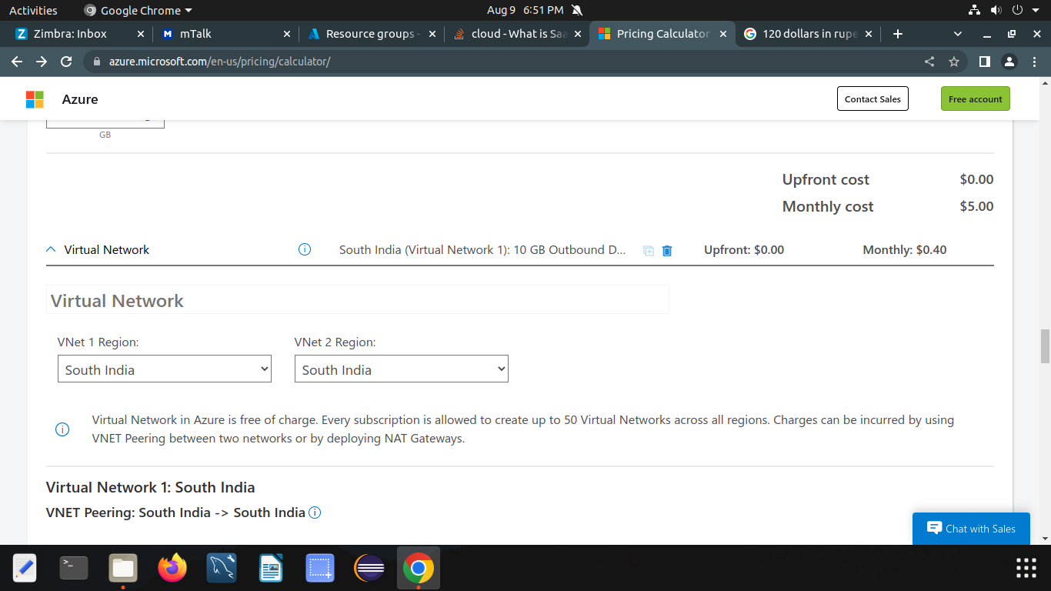
5.save and Export the Excelsheet

